ASSIGNMENT – 2

**NAME**  : P. HANSINI REDDY

**COURSE** : AI ASSISTED CODING

**ROLL NO** : 2403A510D5

**DATE** : 19 AUG 2025

**TASK1:**

**OPEN GOOGLE COLAB:**

**

**CODE & OUTPUT**:

**TASK 2:**

**INPUT:**

**CODE :**

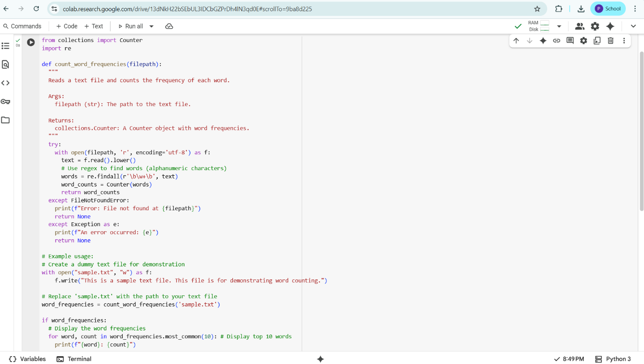

**OUTPUT:**

**EXPLANATION OF CODE BY GEMINI**:

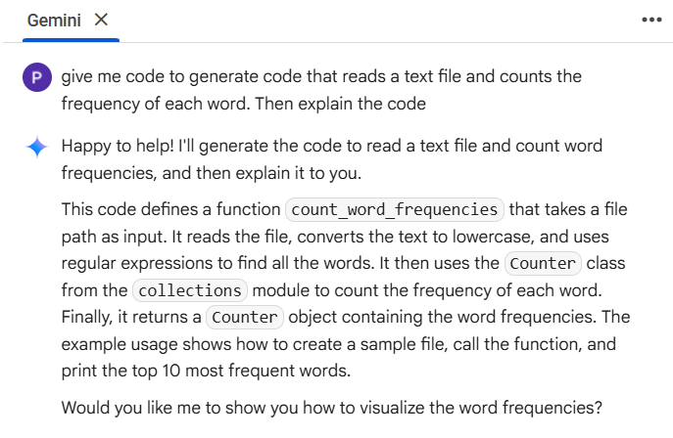

**TASK 3:**

**INPUT IN GEMINI:**

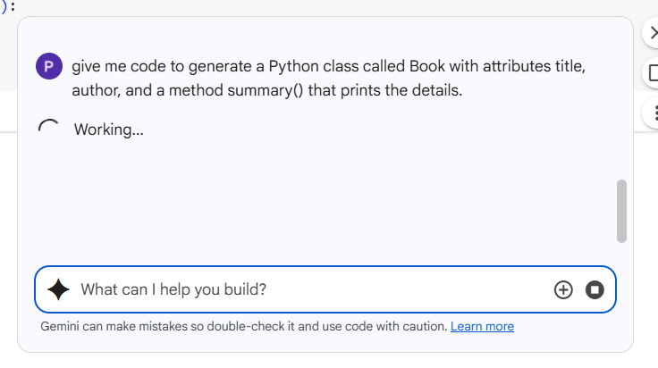

**CODE & OUTPUT IN GEMINI:**

**INPUT & CODE IN COPILOT:**

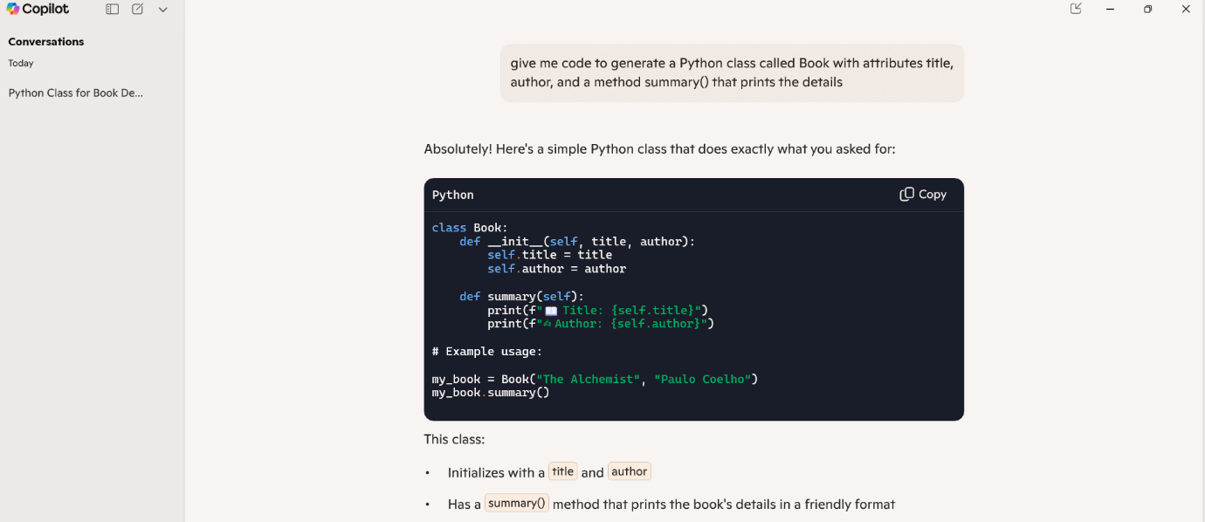

**COMMENTING ON CODE CLARITY AND PERFORMANCE:**

* IN GOOGLE COLAB WE CAN ABLE TO GENERATE THE CODE AND RUN THE CODE TO GET THE OUTPUT WITHOUT DOWNLOADING ANY PYTHON EXTENSION.
* IN COPILOT WE CAN ONLY ABLE TO GENERATE THE CODE WE CANNOT RUN AND GET THE OUTPUT LIKE GOOGLE COLAB.

**TASK 4:**

**INPUT IN GEMINI:**

**CODE & OUTPUT:**

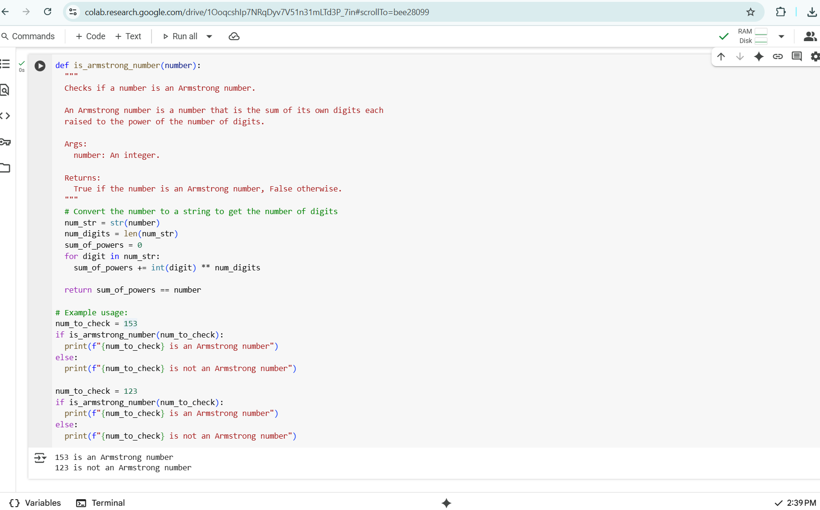

**INPUT & CODE IN COPILOT:**

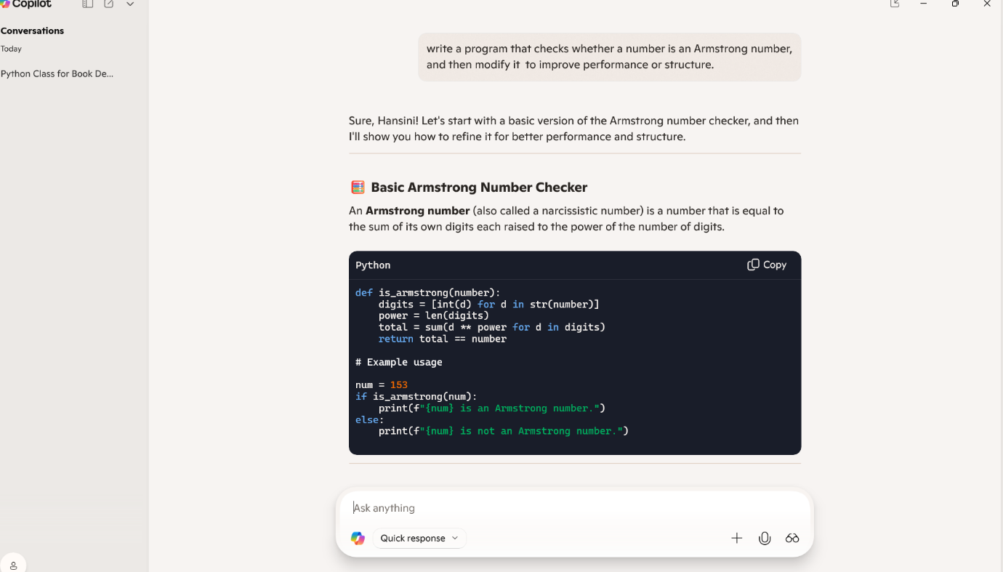

**CHANGES IN COMPARISION OF GEMINI & COPILOT:**

* IN GOOGLE COLAB WE CAN ABLE TO GENERATE THE CODE AND RUN THE CODE TO GET THE OUTPUT WITHOUT DOWNLOADING ANY PYTHON EXTENSION.
* IN COPILOT WE CAN ONLY ABLE TO GENERATE THE CODE WE CANNOT RUN AND GET THE OUTPUT LIKE GOOGLE COLAB.

**TASK 5:**

**INPUT IN GEMINI:**

**CODE & OUTPUT:**

**INPUT & CODE IN COPILOT:**

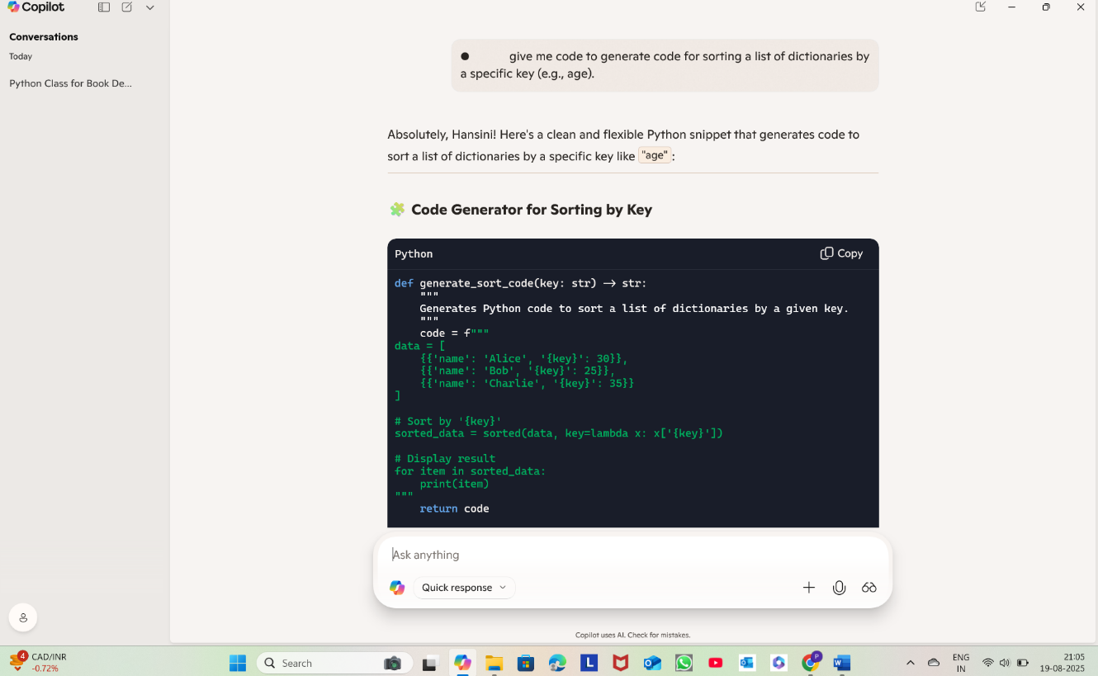

**CHANGES IN COMPARISION OF GEMINI & COPILOT:**

* IN GOOGLE COLAB WE CAN ABLE TO GENERATE THE CODE AND RUN THE CODE TO GET THE OUTPUT WITHOUT DOWNLOADING ANY PYTHON EXTENSION.
* IN COPILOT WE CAN ONLY ABLE TO GENERATE THE CODE WE CANNOT RUN AND GET THE OUTPUT LIKE GOOGLE COLAB.